**58 Number Pattern Programs In Java | Pyramid and Diamond Pattern Programs**

June 17, 2018 by [**javainterviewpoint**](https://www.javainterviewpoint.com/author/javainterviewpoint/) [**166 Comments**](https://www.javainterviewpoint.com/number-pattern-programs-in-java/#comments)

In this article, we will learn to print the different Number pattern programs in [**Java**](https://docs.oracle.com/javase/9/whatsnew/toc.htm#JSNEW-GUID-527735CF-44E1-4144-919B-E7D7CC9CDD4D). This is one of the important Java interview questions for fresher. Let’s look into the below possible number pattern programs

**[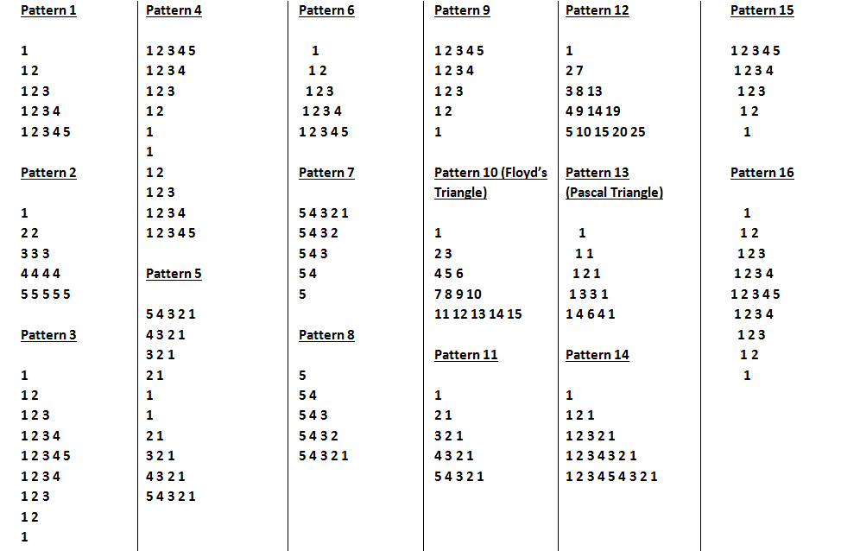](https://javainterviewpoint.com/wp-content/uploads/2018/06/Number-Pattern-Programs-in-Java.png)**

**[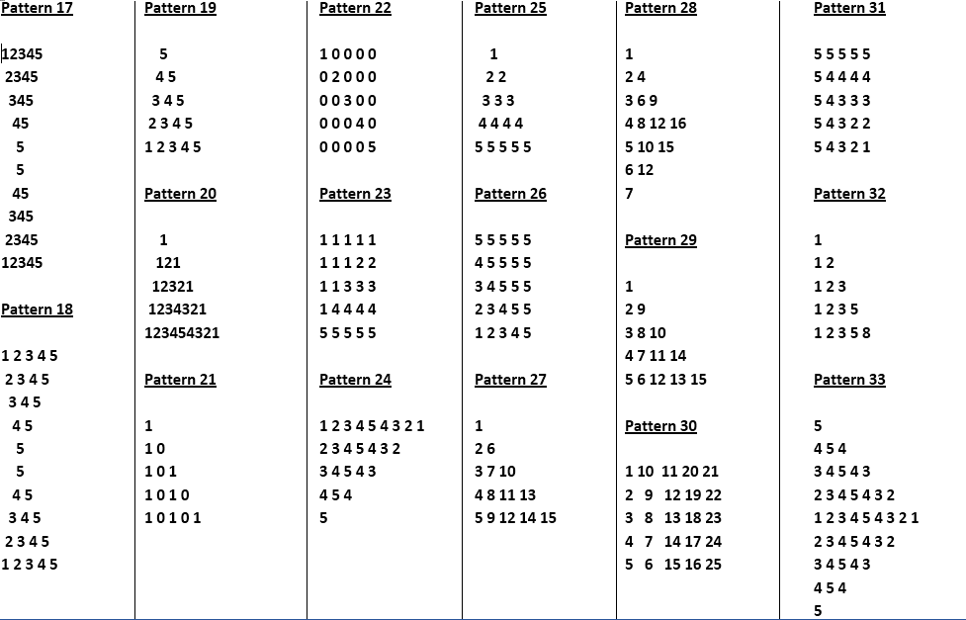](https://javainterviewpoint.com/wp-content/uploads/2018/06/Number-Pattern-Programs-in-Java-5.png)**

**[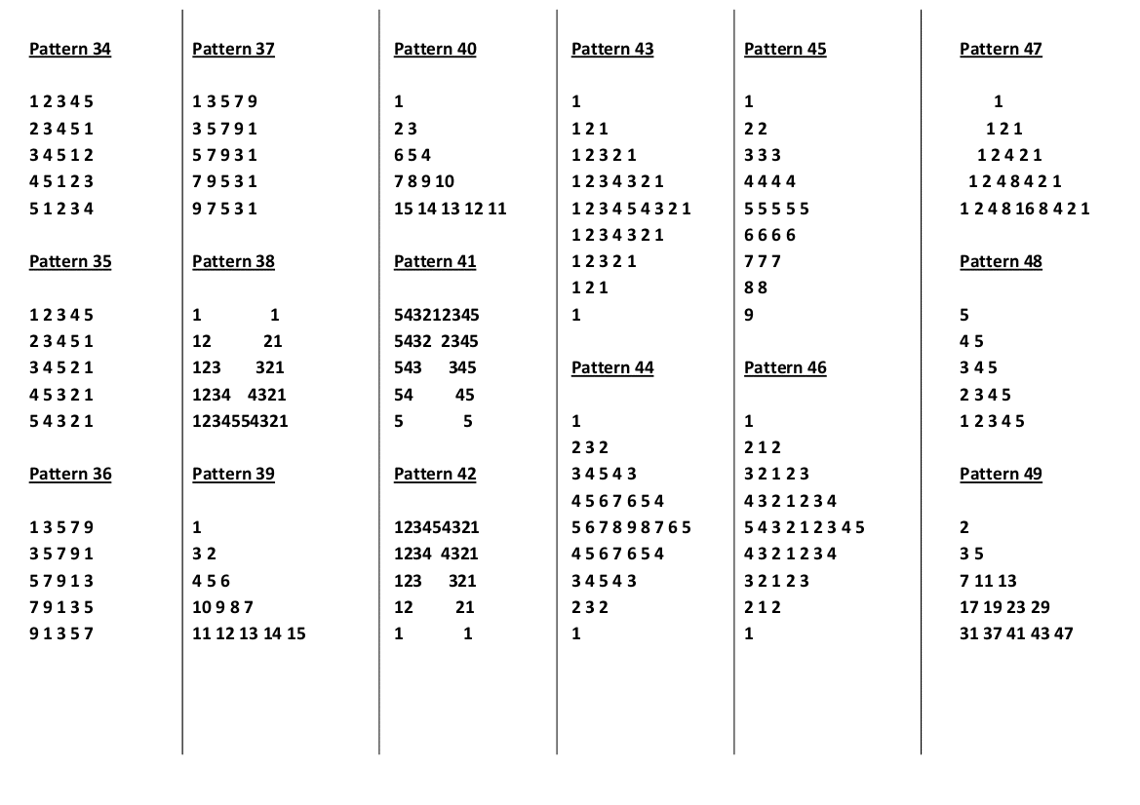](https://javainterviewpoint.com/wp-content/uploads/2018/06/Number-Pattern-Programs-in-Java-8.png)**

**[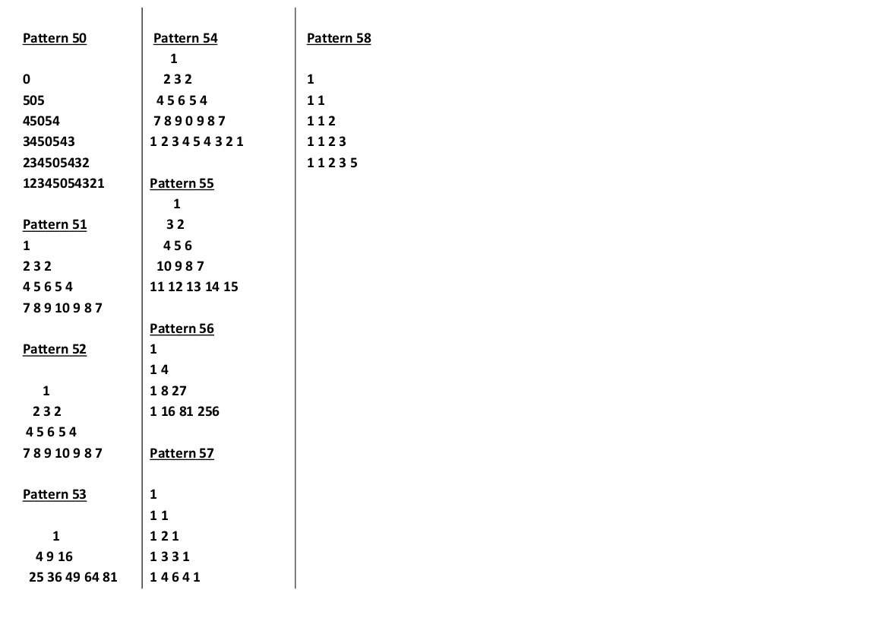](https://javainterviewpoint.azureedge.net/wp-content/uploads/2018/06/Number-Pattern-Programs-in-Java-10.png)**

**Number Pattern Programs In Java**

**Pattern 1:**

package com.javainterviewpoint;

import java.util.Scanner;

public class Pattern1

{

public static void main(String[] args)

{

// Create a new Scanner object

Scanner scanner = new Scanner(System.in);

// Get the number of rows from the user

System.out.println("Enter the number of rows to print the pattern ");

int rows = scanner.nextInt();

System.out.println("** Printing the pattern... **");

for (int i = 1; i <= rows; i++)

{

for (int j = 1; j <= i; j++)

{

System.out.print(j + " ");

}

System.out.println();

}

}

}

**Output**

Enter the number of rows to print the pattern

5

** Printing the pattern... **

1

1 2

1 2 3

1 2 3 4

1 2 3 4 5

**Pattern 2:**

package com.javainterviewpoint;

import java.util.Scanner;

public class Pattern2

{

public static void main(String[] args)

{

// Create a new Scanner object

Scanner scanner = new Scanner(System.in);

// Get the number of rows from the user

System.out.println("Enter the number of rows to print the pattern ");

int rows = scanner.nextInt();

System.out.println("** Printing the pattern... **");

for (int i = 1; i <= rows; i++)

{

for (int j = 1; j <= i; j++)

{

System.out.print(i + " ");

}

System.out.println();

}

}

}

**Output**

Enter the number of rows to print the pattern

5

** Printing the pattern... **

1

2 2

3 3 3

4 4 4 4

5 5 5 5 5

**Pattern 3:**

package com.javainterviewpoint;

import java.util.Scanner;

public class Pattern3

{

public static void main(String[] args)

{

// Create a new Scanner object

Scanner scanner = new Scanner(System.in);

// Get the number of rows from the user

System.out.println("Enter the number of rows to print the pattern ");

int rows = scanner.nextInt();

System.out.println("** Printing the pattern... **");

for (int i = 1; i <= rows; i++)

{

for (int j = 1; j <= i; j++)

{

System.out.print(j + " ");

}

System.out.println();

}

for (int i = rows; i >= 1; i--)

{

for (int j = 1; j < i; j++)

{

System.out.print(j + " ");

}

System.out.println();

}

}

}

**Output**

Enter the number of rows to print the pattern

5

** Printing the pattern... **

1

1 2

1 2 3

1 2 3 4

1 2 3 4 5

1 2 3 4

1 2 3

1 2

1

**Pattern 4:**

package com.javainterviewpoint;

import java.util.Scanner;

public class Pattern4

{

public static void main(String[] args)

{

// Create a new Scanner object

Scanner scanner = new Scanner(System.in);

// Get the number of rows from the user

System.out.println("Enter the number of rows to print the pattern ");

int rows = scanner.nextInt();

System.out.println("** Printing the pattern... **");

for (int i = rows; i >= 1; i--)

{

for (int j = 1; j <= i; j++)

{

System.out.print(j + " ");

}

System.out.println();

}

for (int i = 1; i <= rows; i++)

{

for (int j = 1; j <= i; j++)

{

System.out.print(j + " ");

}

System.out.println();

}

}

}

**Output**

Enter the number of rows to print the pattern

5

** Printing the pattern... **

1 2 3 4 5

1 2 3 4

1 2 3

1 2

1

1

1 2

1 2 3

1 2 3 4

1 2 3 4 5

**Pattern 5:**

package com.javainterviewpoint;

import java.util.Scanner;

public class Pattern5

{

public static void main(String[] args)

{

// Create a new Scanner object

Scanner scanner = new Scanner(System.in);

// Get the number of rows from the user

System.out.println("Enter the number of rows to print the pattern ");

int rows = scanner.nextInt();

System.out.println("** Printing the pattern... **");

for (int i = rows; i >= 1; i--)

{

for (int j = i; j >= 1; j--)

{

System.out.print(j + " ");

}

System.out.println();

}

for (int i = 1; i <= rows; i++)

{

for (int j = i; j >= 1; j--)

{

System.out.print(j + " ");

}

System.out.println();

}

}

}

**Output**

Enter the number of rows to print the pattern

5

** Printing the pattern... **

5 4 3 2 1

4 3 2 1

3 2 1

2 1

1

1

2 1

3 2 1

4 3 2 1

5 4 3 2 1

**Pattern 6:**

package com.javainterviewpoint;

import java.util.Scanner;

public class Pattern6

{

public static void main(String[] args)

{

// Create a new Scanner object

Scanner scanner = new Scanner(System.in);

// Get the number of rows from the user

System.out.println("Enter the number of rows to print the pattern ");

int rows = scanner.nextInt();

System.out.println("** Printing the pattern... **");

for (int i = 1; i <= rows; i++)

{

for (int j = rows; j > i; j--)

{

System.out.print(" ");

}

for (int k = 1; k <= i; k++)

{

System.out.print(k + " ");

}

System.out.println();

}

}

}

**Output**

Enter the number of rows to print the pattern

5

** Printing the pattern... **

1

1 2

1 2 3

1 2 3 4

1 2 3 4 5

**Pattern 7:**

package com.javainterviewpoint;

import java.util.Scanner;

public class Pattern7

{

public static void main(String[] args)

{

// Create a new Scanner object

Scanner scanner = new Scanner(System.in);

// Get the number of rows from the user

System.out.println("Enter the number of rows to print the pattern ");

int rows = scanner.nextInt();

System.out.println("** Printing the pattern... **");

for (int i = 1; i <= rows; i++)

{

for (int j = rows; j >= i; j--)

{

System.out.print(j + " ");

}

System.out.println();

}

}

}

**Output**

Enter the number of rows to print the pattern

5

** Printing the pattern... **

5 4 3 2 1

5 4 3 2

5 4 3

5 4

5

**Pattern 8:**

package com.javainterviewpoint;

import java.util.Scanner;

public class Pattern8

{

public static void main(String[] args)

{

// Create a new Scanner object

Scanner scanner = new Scanner(System.in);

// Get the number of rows from the user

System.out.println("Enter the number of rows to print the pattern ");

int rows = scanner.nextInt();

System.out.println("** Printing the pattern... **");

for (int i = rows; i >= 1; i--)

{

for (int j = rows; j >= i; j--)

{

System.out.print(j + " ");

}

System.out.println();

}

}

}

**Output**

Enter the number of rows to print the pattern

5

** Printing the pattern... **

5

5 4

5 4 3

5 4 3 2

5 4 3 2 1

**Pattern 9:**

package com.javainterviewpoint;

import java.util.Scanner;

public class Pattern9

{

public static void main(String[] args)

{

// Create a new Scanner object

Scanner scanner = new Scanner(System.in);

// Get the number of rows from the user

System.out.println("Enter the number of rows to print the pattern ");

int rows = scanner.nextInt();

System.out.println("** Printing the pattern... **");

for (int i = rows; i >= 1; i--)

{

for (int j = 1; j <= i; j++)

{

System.out.print(j + " ");

}

System.out.println();

}

}

}

**Output**

Enter the number of rows to print the pattern

5

** Printing the pattern... **

1 2 3 4 5

1 2 3 4

1 2 3

1 2

1

**Pattern 10:**

package com.javainterviewpoint;

import java.util.Scanner;

public class Pattern10

{

public static void main(String[] args)

{

// Create a new Scanner object

Scanner scanner = new Scanner(System.in);

// Get the number of rows from the user

System.out.println("Enter the number of rows to print the pattern ");

int rows = scanner.nextInt();

int k = 1;

System.out.println("** Printing the pattern... **");

for (int i = 1; i <= rows; i++)

{

for (int j = 1; j <= i; j++)

{

System.out.print(k + " ");

k++;

}

System.out.println();

}

}

}

**Output**

Enter the number of rows to print the pattern

5

** Printing the pattern... **

1

2 3

4 5 6

7 8 9 10

11 12 13 14 15

**Pattern 11:**

package com.javainterviewpoint;

import java.util.Scanner;

public class Pattern11

{

public static void main(String[] args)

{

// Create a new Scanner object

Scanner scanner = new Scanner(System.in);

// Get the number of rows from the user

System.out.println("Enter the number of rows to print the pattern ");

int rows = scanner.nextInt();

System.out.println("** Printing the pattern... **");

for (int i = 1; i <= rows; i++)

{

for (int j = i; j >= 1; j--)

{

System.out.print(j + " ");

}

System.out.println();

}

}

}

**Output**

Enter the number of rows to print the pattern

5

** Printing the pattern... **

1

2 1

3 2 1

4 3 2 1

5 4 3 2 1

**Pattern 12:**

package com.javainterviewpoint;

import java.util.Scanner;

public class Pattern12

{

public static void main(String[] args)

{

// Create a new Scanner object

Scanner scanner = new Scanner(System.in);

// Get the number of rows from the user

System.out.println("Enter the number of rows to print the pattern ");

int rows = scanner.nextInt();

System.out.println("** Printing the pattern... **");

for (int i = 1; i <= rows; i++)

{

int temp = i;

for (int j = i; j >= 1; j--)

{

System.out.print(temp + " ");

temp = temp + rows;

}

System.out.println();

}

}

}

**Output**

Enter the number of rows to print the pattern

5

** Printing the pattern... **

1

2 7

3 8 13

4 9 14 19

5 10 15 20 25

**Pattern 13:**

package com.javainterviewpoint;

import java.util.Scanner;

public class Pattern13

{

public static void main(String[] args)

{

// Create a new Scanner object

Scanner scanner = new Scanner(System.in);

// Get the number of rows from the user

System.out.println("Enter the number of rows to print the pattern ");

int rows = scanner.nextInt();

System.out.println("** Printing the pattern... **");

for (int i = 1; i <= rows; i++)

{

for (int j = rows; j > i; j--)

{

System.out.print(" ");

}

int temp = 1;

for (int k = 1; k <= i; k++)

{

System.out.print(temp + " ");

temp = temp * (i - k) / (k);

}

System.out.println();

}

}

}

**Output**

Enter the number of rows to print the pattern

5

** Printing the pattern... **

1

1 1

1 2 1

1 3 3 1

1 4 6 4 1

**Pattern 14:**

package com.javainterviewpoint;

import java.util.Scanner;

public class Pattern14

{

public static void main(String[] args)

{

// Create a new Scanner object

Scanner scanner = new Scanner(System.in);

// Get the number of rows from the user

System.out.println("Enter the number of rows to print the pattern ");

int rows = scanner.nextInt();

System.out.println("** Printing the pattern... **");

for (int i = 1; i <= rows; i++)

{

for (int j = 1; j <= i; j++)

{

System.out.print(j + " ");

}

for (int k = i - 1; k >= 1; k--)

{

System.out.print(k + " ");

}

System.out.println();

}

}

}

**Output**

Enter the number of rows to print the pattern

5

** Printing the pattern... **

1

1 2 1

1 2 3 2 1

1 2 3 4 3 2 1

1 2 3 4 5 4 3 2 1

**Pattern 15:**

package com.javainterviewpoint;

import java.util.Scanner;

public class Pattern15

{

public static void main(String[] args)

{

// Create a new Scanner object

Scanner scanner = new Scanner(System.in);

// Get the number of rows from the user

System.out.println("Enter the number of rows to print the pattern ");

int rows = scanner.nextInt();

System.out.println("** Printing the pattern... **");

for (int i = 1; i <= rows; i++)

{

for (int j = 1; j < i; j++)

{

System.out.print(" ");

}

for (int k = 1; k <= rows - i + 1; k++)

{

System.out.print(k + " ");

}

System.out.println();

}

}

}

**Output**

Enter the number of rows to print the pattern

5

** Printing the pattern... **

1 2 3 4 5

1 2 3 4

1 2 3

1 2

1

**Pattern 16:**

package com.javainterviewpoint;

import java.util.Scanner;

public class Pattern16

{

public static void main(String[] args)

{

// Create a new Scanner object

Scanner scanner = new Scanner(System.in);

// Get the number of rows from the user

System.out.println("Enter the number of rows to print the pattern ");

int rows = scanner.nextInt();

System.out.println("** Printing the pattern... **");

for (int i = 1; i <= rows; i++)

{

for (int j = rows; j > i; j--)

{

System.out.print(" ");

}

for (int k = 1; k <= i; k++)

{

System.out.print(k + " ");

}

System.out.println();

}

for (int i = 1; i <= rows; i++)

{

for (int j = 1; j <= i; j++)

{

System.out.print(" ");

}

for (int k = 1; k <= rows - i; k++)

{

System.out.print(k + " ");

}

System.out.println();

}

}

}

**Output**

Enter the number of rows to print the pattern

5

** Printing the pattern... **

1

1 2

1 2 3

1 2 3 4

1 2 3 4 5

1 2 3 4

1 2 3

1 2

1

**Pattern 17:**

package com.javainterviewpoint;

import java.util.Scanner;

public class Pattern17

{

public static void main(String[] args)

{

// Create a new Scanner object

Scanner scanner = new Scanner(System.in);

// Get the number of rows from the user

System.out.println("Enter the number of rows to print the pattern ");

int rows = scanner.nextInt();

System.out.println("** Printing the pattern... **");

for (int i = 1; i <= rows; i++)

{

for (int j = 1; j < i; j++)

{

System.out.print(" ");

}

for (int k = i; k <= rows; k++)

{

System.out.print(k);

}

System.out.println();

}

for (int i = rows; i >= 1; i--)

{

for (int j = 1; j < i; j++)

{

System.out.print(" ");

}

for (int k = i; k <= rows; k++)

{

System.out.print(k);

}

System.out.println();

}

}

}

**Output**

Enter the number of rows to print the pattern

5

** Printing the pattern... **

12345

2345

345

45

5

5

45

345

2345

12345

**Pattern 18:**

package com.javainterviewpoint;

import java.util.Scanner;

public class Pattern18

{

public static void main(String[] args)

{

// Create a new Scanner object

Scanner scanner = new Scanner(System.in);

// Get the number of rows from the user

System.out.println("Enter the number of rows to print the pattern ");

int rows = scanner.nextInt();

System.out.println("** Printing the pattern... **");

for (int i = 1; i <= rows; i++)

{

for (int j = 1; j < i; j++)

{

System.out.print(" ");

}

for (int k = i; k <= rows; k++)

{

System.out.print(k + " ");

}

System.out.println();

}

for (int i = rows; i >= 1; i--)

{

for (int j = 1; j < i; j++)

{

System.out.print(" ");

}

for (int k = i; k <= rows; k++)

{

System.out.print(k + " ");

}

System.out.println();

}

}

}

**Output**

Enter the number of rows to print the pattern

5

** Printing the pattern... **

1 2 3 4 5

2 3 4 5

3 4 5

4 5

5

5

4 5

3 4 5

2 3 4 5

1 2 3 4 5

**Pattern 19:**

package com.javainterviewpoint;

import java.util.Scanner;

public class Pattern19

{

public static void main(String[] args)

{

// Create a new Scanner object

Scanner scanner = new Scanner(System.in);

// Get the number of rows from the user

System.out.println("Enter the number of rows to print the pattern ");

int rows = scanner.nextInt();

System.out.println("** Printing the pattern... **");

for (int i = rows; i >= 1; i--)

{

for (int j = 1; j < i; j++)

{

System.out.print(" ");

}

for (int k = i; k <= rows; k++)

{

System.out.print(k + " ");

}

System.out.println();

}

}

}

**Output**

Enter the number of rows to print the pattern

5

** Printing the pattern... **

5

4 5

3 4 5

2 3 4 5

1 2 3 4 5

**Pattern 20:**

package com.javainterviewpoint;

import java.util.Scanner;

public class Pattern20

{

public static void main(String[] args)

{

// Create a new Scanner object

Scanner scanner = new Scanner(System.in);

// Get the number of rows from the user

System.out.println("Enter the number of rows to print the pattern ");

int rows = scanner.nextInt();

System.out.println("** Printing the pattern... **");

for (int i = 1; i <= rows; i++)

{

for (int j = rows; j > i; j--)

{

System.out.print(" ");

}

for (int k = 1; k <= i; k++)

{

System.out.print(k);

}

for (int l = i - 1; l >= 1; l--)

{

System.out.print(l);

}

System.out.println();

}

}

}

**Output**

Enter the number of rows to print the pattern

5

** Printing the pattern... **

1

121

12321

1234321

123454321

**Pattern 21:**

package com.javainterviewpoint;

import java.util.Scanner;

public class Pattern21

{

public static void main(String[] args)

{

// Create a new Scanner object

Scanner scanner = new Scanner(System.in);

// Get the number of rows from the user

System.out.println("Enter the number of rows to print the pattern ");

int rows = scanner.nextInt();

System.out.println("** Printing the pattern... **");

for (int i = 1; i <= rows; i++)

{

for (int j = 1; j <= i; j++)

{

System.out.print(j % 2 + " ");

}

System.out.println();

}

}

}

**Output**

Enter the number of rows to print the pattern

5

** Printing the pattern... **

1

1 0

1 0 1

1 0 1 0

1 0 1 0 1

**Pattern 22:**

package com.javainterviewpoint;

import java.util.Scanner;

public class Pattern22

{

public static void main(String[] args)

{

// Create a new Scanner object

Scanner scanner = new Scanner(System.in);

// Get the number of rows from the user

System.out.println("Enter the number of rows to print the pattern ");

int rows = scanner.nextInt();

System.out.println("** Printing the pattern... **");

for (int i = 1; i <= rows; i++)

{

for (int j = 1; j < i; j++)

{

System.out.print("0 ");

}

System.out.print(i + " ");

for (int k = i; k < rows; k++)

{

System.out.print("0 ");

}

System.out.println();

}

}

}

**Output**

Enter the number of rows to print the pattern

5

** Printing the pattern... **

1 0 0 0 0

0 2 0 0 0

0 0 3 0 0

0 0 0 4 0

0 0 0 0 5

**Pattern 23:**

package com.javainterviewpoint;

import java.util.Scanner;

public class Pattern23

{

public static void main(String[] args)

{

// Create a new Scanner object

Scanner scanner = new Scanner(System.in);

// Get the number of rows from the user

System.out.println("Enter the number of rows to print the pattern ");

int rows = scanner.nextInt();

System.out.println("** Printing the pattern... **");

for (int i = 1; i <= rows; i++)

{

for (int j = rows; j > i; j--)

{

System.out.print(1 + " ");

}

for (int k = 1; k <= i; k++)

{

System.out.print(i + " ");

}

System.out.println();

}

}

}

**Output**

Enter the number of rows to print the pattern

5

** Printing the pattern... **

1 1 1 1 1

1 1 1 2 2

1 1 3 3 3

1 4 4 4 4

5 5 5 5 5

**Pattern 24:**

package com.javainterviewpoint;

import java.util.Scanner;

public class Pattern24

{

public static void main(String[] args)

{

// Create a new Scanner object

Scanner scanner = new Scanner(System.in);

// Get the number of rows from the user

System.out.println("Enter the number of rows to print the pattern ");

int rows = scanner.nextInt();

System.out.println("** Printing the pattern... **");

for (int i = 1; i <= rows; i++)

{

for (int j = i; j <= rows; j++)

{

System.out.print(j + " ");

}

for (int k = rows - 1; k >= i; k--)

{

System.out.print(k + " ");

}

System.out.println();

}

}

}

**Output**

Enter the number of rows to print the pattern

5

** Printing the pattern... **

1 2 3 4 5 4 3 2 1

2 3 4 5 4 3 2

3 4 5 4 3

4 5 4

5

**Pattern 25:**

package com.javainterviewpoint;

import java.util.Scanner;

public class Pattern25

{

public static void main(String[] args)

{

// Create a new Scanner object

Scanner scanner = new Scanner(System.in);

// Get the number of rows from the user

System.out.println("Enter the number of rows to print the pattern ");

int rows = scanner.nextInt();

System.out.println("** Printing the pattern... **");

for (int i = 1; i <= rows; i++)

{

for (int j = rows; j > i; j--)

{

System.out.print(" ");

}

for (int k = 1; k <= i; k++)

{

System.out.print(i + " ");

}

System.out.println();

}

}

}

**Output**

Enter the number of rows to print the pattern

5

** Printing the pattern... **

1

2 2

3 3 3

4 4 4 4

5 5 5 5 5

**Pattern 26:**

package com.javainterviewpoint;

import java.util.Scanner;

public class Pattern26

{

public static void main(String[] args)

{

// Create a new Scanner object

Scanner scanner = new Scanner(System.in);

// Get the number of rows from the user

System.out.println("Enter the number of rows to print the pattern ");

int rows = scanner.nextInt();

System.out.println("** Printing the pattern... **");

for (int i = rows; i >= 1; i--)

{

for (int j = i; j < rows; j++)

{

System.out.print(j + " ");

}

for (int k = rows - i; k < rows; k++)

{

System.out.print(5 + " ");

}

System.out.println();

}

}

}

**Output**

Enter the number of rows to print the pattern

5

** Printing the pattern... **

5 5 5 5 5

4 5 5 5 5

3 4 5 5 5

2 3 4 5 5

1 2 3 4 5

**Pattern 27:**

package com.javainterviewpoint;

import java.util.Scanner;

public class Pattern27

{

public static void main(String[] args)

{

// Create a new Scanner object

Scanner scanner = new Scanner(System.in);

// Get the number of rows from the user

System.out.println("Enter the number of rows to print the pattern ");

int rows = scanner.nextInt();

int k = 1;

System.out.println("** Printing the pattern... **");

for (int i = 1; i <= rows; i++)

{

k=i;

for (int j = 1; j <= i; j++)

{

System.out.print(k + " ");

k = k + rows - j;

}

System.out.println();

}

}

}

**Output**

Enter the number of rows to print the pattern

5

** Printing the pattern... **

1

2 6

3 7 10

4 8 11 13

5 9 12 14 15

**Pattern 28:**

package com.javainterviewpoint;

import java.util.Scanner;

public class Pattern28

{

public static void main(String[] args)

{

// Create a new Scanner object

Scanner scanner = new Scanner(System.in);

// Get the number of rows from the user

System.out.println("Enter the number of rows to print the pattern ");

int rows = scanner.nextInt();

System.out.println("** Printing the pattern... **");

int temp = 1;

for(int i=1; i<=rows/2+1; i++)

{

for(int j=1;j<=i;j++)

{

System.out.print(temp*j+" ");

}

System.out.println();

temp++;

}

for(int i=1; i<=rows/2; i++)

{

for(int j=1;j<=rows/2+1-i;j++)

{

System.out.print(temp*j+" ");

}

System.out.println();

temp++;

}

}

}

**Output**

Enter the number of rows to print the pattern

7

** Printing the pattern... **

1

2 4

3 6 9

4 8 12 16

5 10 15

6 12

7

**Pattern 29:**

package com.javainterviewpoint;

import java.util.Scanner;

public class Pattern29

{

public static void main(String[] args)

{

// Create a new Scanner object

Scanner scanner = new Scanner(System.in);

// Get the number of rows from the user

System.out.println("Enter the number of rows to print the pattern ");

int rows = scanner.nextInt();

System.out.println("** Printing the pattern... **");

for (int i = 0; i < rows; i++)

{

for (int j = 0; j <= i; j++)

{

if (j % 2 == 0)

{

System.out.print(1 + j * rows - (j - 1) * j / 2 + i - j + " ");

} else

{

System.out.print(1 + j * rows - (j - 1) * j / 2 + rows - 1 - i + " ");

}

}

System.out.println();

}

}

}

**Output**

Enter the number of rows to print the pattern

5

** Printing the pattern... **

1

2 9

3 8 10

4 7 11 14

5 6 12 13 15

**Pattern 30:**

package com.javainterviewpoint;

import java.util.Scanner;

public class Pattern30

{

public static void main(String[] args)

{

// Create a new Scanner object

Scanner scanner = new Scanner(System.in);

// Get the number of rows from the user

System.out.println("Enter the number of rows to print the pattern ");

int rows = scanner.nextInt();

System.out.println("** Printing the pattern... **");

for (int i = 0; i < rows; i++)

{

for (int j = 0; j < rows; j++)

{

if (j % 2 == 0)

System.out.print((rows * (j)) + i + 1 + " ");

else

System.out.print((rows * (j + 1)) - i + " ");

}

System.out.print("\n");

}

}

}

**Output**

Enter the number of rows to print the pattern

5

** Printing the pattern... **

1 10 11 20 21

2 9 12 19 22

3 8 13 18 23

4 7 14 17 24

5 6 15 16 25

**Pattern 31:**

package com.javainterviewpoint;

import java.util.Scanner;

public class Pattern31

{

public static void main(String[] args)

{

// Create a new Scanner object

Scanner scanner = new Scanner(System.in);

// Get the number of rows from the user

System.out.println("Enter the number of rows to print the pattern ");

int rows = scanner.nextInt();

int temp = 0;

System.out.println("** Printing the pattern... **");

for (int i = rows; i >= 1; i--)

{

for (int j = rows ; j >= i; j--)

{

System.out.print(j + " ");

temp =j;

}

for (int k = rows - i+1; k < rows; k++)

{

System.out.print(temp + " ");

}

System.out.println();

}

}

}

**Output**

Enter the number of rows to print the pattern

5

** Printing the pattern... **

5 5 5 5 5

5 4 4 4 4

5 4 3 3 3

5 4 3 2 2

5 4 3 2 1

**Pattern 32: [ Fibonacci Triangle Pattern ]**

package com.javainterviewpoint;

import java.util.Scanner;

public class Pattern32

{

public static void main(String[] args)

{

// Create a new Scanner object

Scanner scanner = new Scanner(System.in);

// Get the number of rows from the user

System.out.println("Enter the number of rows to print the pattern ");

int rows = scanner.nextInt();

System.out.println("** Printing the pattern... **");

for (int i = 1; i <= rows; i++)

{

int a = 0;

int b = 1;

for (int j = 1; j <= i; j++)

{

int c = a + b;

System.out.print(c + " ");

a = b;

b = c;

}

System.out.println();

}

}

}

**Output**

Enter the number of rows to print the pattern

5

** Printing the pattern... **

1

1 2

1 2 3

1 2 3 5

1 2 3 5 8

**Pattern 33:**

package com.javainterviewpoint;

import java.util.Scanner;

public class Pattern33

{

public static void main(String[] args)

{

// Create a new Scanner object

Scanner scanner = new Scanner(System.in);

// Get the number of rows from the user

System.out.println("Enter the number of rows to print the pattern ");

int rows = scanner.nextInt();

System.out.println("** Printing the pattern... **");

for (int i = rows; i >= 1; i--)

{

for (int j = i; j <= rows; j++)

{

System.out.print(j + " ");

}

for (int k = rows-1; k >= i; k--)

{

System.out.print(k + " ");

}

System.out.println();

}

for (int i = 2; i <= rows; i++)

{

for (int j = i; j <= rows; j++)

{

System.out.print(j + " ");

}

for (int k = rows-1; k >= i; k--)

{

System.out.print(k + " ");

}

System.out.println();

}

}

}

**Output**

Enter the number of rows to print the pattern

5

** Printing the pattern... **

5

4 5 4

3 4 5 4 3

2 3 4 5 4 3 2

1 2 3 4 5 4 3 2 1

2 3 4 5 4 3 2

3 4 5 4 3

4 5 4

5

**Pattern 34:**

package com.javainterviewpoint;

import java.util.Scanner;

public class Pattern34

{

public static void main(String[] args)

{

// Create a new Scanner object

Scanner scanner = new Scanner(System.in);

// Get the number of rows from the user

System.out.println("Enter the number of rows to print the pattern ");

int rows = scanner.nextInt();

System.out.println("** Printing the pattern... **");

for (int i = 1; i <= rows; i++)

{

int j = i;

for (int k = 1; k <= rows; k++)

{

System.out.print(j + " ");

j++;

if (j > rows)

j = 1;

}

System.out.println();

}

scanner.close();

}

}

**Output**

Enter the number of rows to print the pattern

5

** Printing the pattern... **

1 2 3 4 5

2 3 4 5 1

3 4 5 1 2

4 5 1 2 3

5 1 2 3 4

**Pattern 35:**

package com.javainterviewpoint;

import java.util.Scanner;

public class Pattern35

{

public static void main(String[] args)

{

// Create a new Scanner object

Scanner scanner = new Scanner(System.in);

// Get the number of rows from the user

System.out.println("Enter the number of rows to print the pattern ");

int rows = scanner.nextInt();

System.out.println("** Printing the pattern... **");

for (int i = 1; i <= rows; i++)

{

for (int j = i; j <= rows; j++)

{

System.out.print(j + " ");

}

for(int k = i-1; k >= 1; k--)

{

System.out.print(k + " ");

}

System.out.println();

}

scanner.close();

}

}

**Output**

Enter the number of rows to print the pattern

5

** Printing the pattern... **

1 2 3 4 5

2 3 4 5 1

3 4 5 2 1

4 5 3 2 1

5 4 3 2 1

**Pattern 36:**

package com.javainterviewpoint;

import java.util.Scanner;

public class Pattern36

{

public static void main(String[] args)

{

// Create a new Scanner object

Scanner scanner = new Scanner(System.in);

// Get the number of rows from the user

System.out.println("Enter the number of rows to print the pattern ");

int rows = scanner.nextInt();

System.out.println("** Printing the pattern... **");

for (int i = 1; i <= rows; i++)

{

int j = (i * 2) - 1;

for (int k = 1; k <= rows; k++)

{

System.out.print(j + " ");

j += 2;

if (j > (rows * 2) - 1)

j = 1;

}

System.out.println();

}

scanner.close();

}

}

**Output**

Enter the number of rows to print the pattern

5

** Printing the pattern... **

1 3 5 7 9

3 5 7 9 1

5 7 9 1 3

7 9 1 3 5

9 1 3 5 7

**Pattern 37:**

package com.javainterviewpoint;

import java.util.Scanner;

public class Pattern37

{

public static void main(String[] args)

{

// Create a new Scanner object

Scanner scanner = new Scanner(System.in);

// Get the number of rows from the user

System.out.println("Enter the number of rows to print the pattern ");

int rows = scanner.nextInt();

System.out.println("** Printing the pattern... **");

for (int i = 1; i <= rows; i++)

{

int j = (i * 2) - 1;

for (int k = i; k <= rows; k++)

{

System.out.print(j + " ");

j += 2;

}

for (int l = (i * 2) - 3; l >= 1; l-=2)

{

System.out.print(l + " ");

}

System.out.println();

}

scanner.close();

}

}

**Output**

Enter the number of rows to print the pattern

5

** Printing the pattern... **

1 3 5 7 9

3 5 7 9 1

5 7 9 3 1

7 9 5 3 1

9 7 5 3 1

**Pattern 38:**

package com.javainterviewpoint;

import java.util.Scanner;

public class Pattern38

{

public static void main(String[] args)

{

// Create a new Scanner object

Scanner scanner = new Scanner(System.in);

// Get the number of rows from the user

System.out.println("Enter the number of rows to print the pattern ");

int rows = scanner.nextInt();

System.out.println("** Printing the pattern... **");

for (int i = 1; i <= rows; i++)

{

for (int j = 1; j <= i; j++)

{

System.out.print(j);

}

for (int j= i*2 ; j < rows*2; j++)

{

System.out.print(" ");

}

for (int l = i; l >= 1; l--)

{

System.out.print(l);

}

System.out.println();

}

scanner.close();

}

}

**Output**

Enter the number of rows to print the pattern

5

** Printing the pattern... **

1 1

12 21

123 321

1234 4321

1234554321

**Pattern 39:**

package com.javainterviewpoint;

import java.util.Scanner;

public class Pattern39

{

public static void main(String[] args)

{

int currentRow = 1;

int counter = 1;

// Create a new Scanner object

Scanner scanner = new Scanner(System.in);

// Get the number of rows from the user

System.out.println("Enter the number of rows to print the pattern ");

int rows = scanner.nextInt();

System.out.println("** Printing the pattern... **");

for (int i=1; i<= rows; i++)

{

if (i % 2 == 0)

{

int reverse = currentRow + counter - 1;

for (int j = 0; j<i; j++)

{

System.out.print(reverse-- +" ");

counter++;

}

}

else

{

for (int j = 1; j<=i; j++)

{

System.out.print(counter +" ");

counter++;

}

}

System.out.println();

currentRow++;

}

}

}

**Output**

Enter the number of rows to print the pattern

5

** Printing the pattern... **

1

3 2

4 5 6

10 9 8 7

11 12 13 14 15

**Pattern 40:**

package com.javainterviewpoint;

import java.util.Scanner;

public class Pattern40

{

public static void main(String[] args)

{

int currentRow = 1;

int counter = 1;

// Create a new Scanner object

Scanner scanner = new Scanner(System.in);

// Get the number of rows from the user

System.out.println("Enter the number of rows to print the pattern ");

int rows = scanner.nextInt();

System.out.println("** Printing the pattern... **");

for (int i=1; i<= rows; i++)

{

if (i % 2 == 0)

{

for (int j = 1; j<=i; j++)

{

System.out.print(counter +" ");

counter++;

}

}

else

{

int reverse = currentRow + counter - 1;

for (int j = 0; j<i; j++)

{

System.out.print(reverse-- +" ");

counter++;

}

}

System.out.println();

currentRow++;

}

}

}

**Output**

Enter the number of rows to print the pattern

5

** Printing the pattern... **

1

2 3

6 5 4

7 8 9 10

15 14 13 12 11

**Pattern 41:**

package com.javainterviewpoint;

import java.util.Scanner;

public class Pattern41

{

public static void main(String[] args)

{

// Create a new Scanner object

Scanner scanner = new Scanner(System.in);

// Get the number of rows from the user

System.out.println("Enter the number of rows to print the pattern ");

int rows = scanner.nextInt();

System.out.println("** Printing the pattern... **");

for (int i = rows; i >= 1; i--)

{

for (int j = rows; j >= 1+rows-i; j--)

{

System.out.print(j);

}

for (int j= i*2 ; j < rows*2-1; j++)

{

System.out.print(" ");

}

for (int l = 1+rows-i; l <=rows; l++)

{

if(l!=1)

System.out.print(l);

}

System.out.println();

}

scanner.close();

}

}

**Output**

Enter the number of rows to print the pattern

5

** Printing the pattern... **

543212345

5432 2345

543 345

54 45

5 5

**Pattern 42:**

package com.javainterviewpoint;

import java.util.Scanner;

public class Pattern42

{

public static void main(String[] args)

{

// Create a new Scanner object

Scanner scanner = new Scanner(System.in);

// Get the number of rows from the user

System.out.println("Enter the number of rows to print the pattern ");

int rows = scanner.nextInt();

System.out.println("** Printing the pattern... **");

for (int i = rows; i >= 1; i--)

{

for (int j = 1; j <= i; j++)

{

System.out.print(j);

}

for (int j= i*2 ; j < rows*2-1; j++)

{

System.out.print(" ");

}

for (int l = i; l >= 1; l--)

{

if(l!=rows)

System.out.print(l);

}

System.out.println();

}

scanner.close();

}

}

**Output**

Enter the number of rows to print the pattern

5

** Printing the pattern... **

123454321

1234 4321

123 321

12 21

1 1

**Pattern 43:**

package com.javainterviewpoint;

import java.util.Scanner;

public class Pattern43

{

public static void main(String[] args)

{

// Create a new Scanner object

Scanner scanner = new Scanner(System.in);

// Get the number of rows from the user

System.out.println("Enter the number of rows to print the pattern ");

int rows = scanner.nextInt();

System.out.println("** Printing the pattern... **");

// Top Half

for (int i = 1; i <= rows; i++)

{

for (int j = 1; j <= i; j++)

{

System.out.print(j + " ");

}

for (int k = i - 1; k >= 1; k--)

{

System.out.print(k + " ");

}

System.out.println();

}

// Bottom Half

for (int i = rows-1; i >= 1; i--)

{

for (int j = 1; j <= i; j++)

{

System.out.print(j + " ");

}

for (int k = i - 1; k >= 1; k--)

{

System.out.print(k + " ");

}

System.out.println();

}

}

}

**Output**

Enter the number of rows to print the pattern

5

** Printing the pattern... **

1

1 2 1

1 2 3 2 1

1 2 3 4 3 2 1

1 2 3 4 5 4 3 2 1

1 2 3 4 3 2 1

1 2 3 2 1

1 2 1

1

**Pattern 44:**

package com.javainterviewpoint;

import java.util.Scanner;

public class Pattern44

{

public static void main(String[] args)

{

// Create a new Scanner object

Scanner scanner = new Scanner(System.in);

// Get the number of rows from the user

System.out.println("Enter the number of rows to print the pattern ");

int rows = scanner.nextInt();

System.out.println("** Printing the pattern... **");

// Top Half

for (int i = 1; i <= rows; i++)

{

int temp = i;

for (int j = 1; j <= i; j++)

{

System.out.print(temp + " ");

temp = temp + 1;

}

temp = temp - 2;

for (int k = i - 1; k >= 1; k--)

{

System.out.print(temp + " ");

temp = temp - 1;

}

System.out.println();

}

// Bottom Half

for (int i = rows - 1; i >= 1; i--)

{

int temp = i;

for (int j = 1; j <= i; j++)

{

System.out.print(temp + " ");

temp = temp + 1;

}

temp = temp - 2;

for (int k = i - 1; k >= 1; k--)

{

System.out.print(temp + " ");

temp = temp - 1;

}

System.out.println();

}

}

}

**Output**

Enter the number of rows to print the pattern

5

** Printing the pattern... **

1

2 3 2

3 4 5 4 3

4 5 6 7 6 5 4

5 6 7 8 9 8 7 6 5

4 5 6 7 6 5 4

3 4 5 4 3

2 3 2

1

**Pattern 45:**

package com.javainterviewpoint;

import java.util.Scanner;

public class Pattern45

{

public static void main(String[] args)

{

// Create a new Scanner object

Scanner scanner = new Scanner(System.in);

// Get the number of rows from the user

System.out.println("Enter the number of rows to print the pattern ");

int rows = scanner.nextInt();

System.out.println("** Printing the pattern... **");

int temp = 1;

for (int i = 1; i <= rows; i++)

{

for (int k = 1; k <= i; k++)

{

System.out.print(temp + " ");

}

temp++;

System.out.println();

}

for (int i = rows - 1; i >= 1; i--)

{

for (int k = i; k >= 1; k--)

{

System.out.print(temp + " ");

}

temp++;

System.out.println();

}

}

}

**Output**

Enter the number of rows to print the pattern

5

** Printing the pattern... **

1

2 2

3 3 3

4 4 4 4

5 5 5 5 5

6 6 6 6

7 7 7

8 8

9

**Pattern 46:**

package com.javainterviewpoint;

import java.util.Scanner;

public class Pattern46

{

public static void main(String[] args)

{

// Create a new Scanner object

Scanner scanner = new Scanner(System.in);

// Get the number of rows from the user

System.out.println("Enter the number of rows to print the pattern ");

int rows = scanner.nextInt();

System.out.println("** Printing the pattern... **");

for (int i = 1; i <= rows; i++)

{

for (int k = i; k >= 1; k--)

{

System.out.print(k + " ");

}

for (int l = 2; l <= i; l++)

{

System.out.print(l + " ");

}

System.out.println();

}

for (int i = rows - 1; i >= 1; i--)

{

for (int k = i; k >= 1; k--)

{

System.out.print(k + " ");

}

for (int l = 2; l <= i; l++)

{

System.out.print(l + " ");

}

System.out.println();

}

}

}

**Output**

Enter the number of rows to print the pattern

5

** Printing the pattern... **

1

2 1 2

3 2 1 2 3

4 3 2 1 2 3 4

5 4 3 2 1 2 3 4 5

4 3 2 1 2 3 4

3 2 1 2 3

2 1 2

1

**Pattern 47:**

package com.javainterviewpoint;

import java.util.Scanner;

public class Pattern47

{

public static void main(String[] args)

{

// Create a new Scanner object

Scanner scanner = new Scanner(System.in);

// Get the number of rows from the user

System.out.println("Enter the number of rows to print the pattern ");

int rows = scanner.nextInt();

System.out.println("** Printing the pattern... **");

for (int i = 1; i <= rows; i++)

{

for (int j = rows; j > i; j--)

{

System.out.print(" ");

}

int val1 = 1;

for (int k = 1; k <= i; k++)

{

System.out.print(val1 + " ");

val1 = val1 * 2;

}

val1 = val1 / 4;

for (int l = i - 1; l >= 1; l--)

{

System.out.print(val1 + " ");

val1 = val1 / 2;

}

System.out.println();

}

}

}

**Output**

Enter the number of rows to print the pattern

5

** Printing the pattern... **

1

1 2 1

1 2 4 2 1

1 2 4 8 4 2 1

1 2 4 8 16 8 4 2 1

**Pattern 48:**

package com.javainterviewpoint;

import java.util.Scanner;

public class Pattern48

{

public static void main(String[] args)

{

// Create a new Scanner object

Scanner scanner = new Scanner(System.in);

// Get the number of rows from the user

System.out.println("Enter the number of rows to print the pattern ");

int rows = scanner.nextInt();

System.out.println("** Printing the pattern... **");

for (int i = rows; i >= 1; i--)

{

for (int j = i; j <= rows; j++)

{

System.out.print(j + " ");

}

System.out.println();

}

}

}

**Output**

Enter the number of rows to print the pattern

5

** Printing the pattern... **

5

4 5

3 4 5

2 3 4 5

1 2 3 4 5

**Pattern 49:**

package com.javainterviewpoint;

import java.util.Scanner;

public class Pattern49

{

public static void main(String[] args)

{

// Create a new Scanner object

Scanner scanner = new Scanner(System.in);

// Get the number of rows from the user

System.out.println("Enter the number of rows to print the pattern ");

int rows = scanner.nextInt();

System.out.println("** Printing the pattern... **");

int temp = 2;

for (int i = 1; i <= rows; i++)

{

for (int j = 1; j <= i; j++)

{

while (!isPrime(temp))

{

temp++;

}

System.out.print(temp + " ");

temp++;

}

System.out.println();

}

}

public static boolean isPrime(int num)

{

boolean flag = false;

for (int k = 2; k <= num / 2; k++)

{

if (num % k == 0)

{

flag = true;

break;

}

}

if (flag)

return false;

return true;

}

}

**Output**

Enter the number of rows to print the pattern

5

** Printing the pattern... **

2

3 5

7 11 13

17 19 23 29

31 37 41 43 47

**Pattern 50:**

package com.javainterviewpoint;

import java.util.Scanner;

public class Pattern50

{

public static void main(String[] args)

{

// Create a new Scanner object

Scanner scanner = new Scanner(System.in);

// Get the number of rows from the user

System.out.println("Enter the number of rows to print the pattern ");

int rows = scanner.nextInt();

System.out.println("** Printing the pattern... **");

System.out.println("0");

for (int i = rows; i >= 1; i--)

{

for (int j = i; j <= rows; j++) { System.out.print(j); } System.out.print("0"); for (int k = rows; k >= i; k--)

{

System.out.print(k);

}

System.out.println();

}

}

}

**Output**

Enter the number of rows to print the pattern

5

** Printing the pattern... **

0

505

45054

3450543

234505432

12345054321

**Pattern 51:**

package com.javainterviewpoint;

import java.util.Scanner;

public class Pattern51

{

public static void main(String[] args)

{

// Create a new Scanner object

Scanner scanner = new Scanner(System.in);

// Get the number of rows from the user

System.out.println("Enter the number of rows to print the pattern ");

int rows = scanner.nextInt();

System.out.println("** Printing the pattern... **");

int temp = 1;

for (int i = 1; i <= rows; i++)

{

for (int j = 1; j <= i; j++)

{

System.out.print(temp + " ");

temp++;

}

int temp1 = temp - 1;

for (int k = 2; k <= i; k++)

{

System.out.print(--temp1 + " ");

}

System.out.println();

}

}

}

**Output**

Enter the number of rows to print the pattern

5

** Printing the pattern... **

1

2 3 2

4 5 6 5 4

7 8 9 10 9 8 7

11 12 13 14 15 14 13 12 11

**Pattern 52:**

package com.javainterviewpoint;

import java.util.Scanner;

public class Pattern52

{

public static void main(String[] args)

{

// Create a new Scanner object

Scanner scanner = new Scanner(System.in);

// Get the number of rows from the user

System.out.println("Enter the number of rows to print the pattern ");

int rows = scanner.nextInt();

System.out.println("** Printing the pattern... **");

int temp = 1;

for (int i = 1; i <= rows; i++) { for (int l = rows; l > i; l--)

{

System.out.print(" ");

}

for (int j = 1; j <= i; j++)

{

System.out.print(temp + " ");

temp++;

}

int temp1 = temp - 1;

for (int k = 2; k <= i; k++)

{

System.out.print(--temp1 + " ");

}

System.out.println();

}

}

}

**Output**

Enter the number of rows to print the pattern

5

** Printing the pattern... **

1

2 3 2

4 5 6 5 4

7 8 9 10 9 8 7

11 12 13 14 15 14 13 12 11

**Pattern 53:**

package com.javainterviewpoint;

import java.util.Scanner;

public class Pattern53

{

public static void main(String[] args)

{

// Create a new Scanner object

Scanner scanner = new Scanner(System.in);

// Get the number of rows from the user

System.out.println("Enter the number of rows to print the pattern ");

int rows = scanner.nextInt();

int temp = 1;

System.out.println("** Printing the pattern... **");

for (int i = 1; i <= rows; i++) { for (int l = rows; l > i; l--)

{

System.out.print(" ");

}

for (int j = 1; j <= (i * 2 - 1); j++)

{

System.out.print((int) Math.pow(temp, 2) + " ");

temp++;

}

System.out.println();

}

}

}

**Output**

Enter the number of rows to print the pattern

4

** Printing the pattern... **

1

4 9 16

25 36 49 64 81

100 121 144 169 196 225 256

**Pattern 54:**

package com.javainterviewpoint;

import java.util.Scanner;

public class Pattern54

{

public static void main(String[] args)

{

// Create a new Scanner object

Scanner scanner = new Scanner(System.in);

// Get the number of rows from the user

System.out.println("Enter the number of rows to print the pattern ");

int rows = scanner.nextInt();

System.out.println("** Printing the pattern... **");

int temp = 1;

for (int i = 1; i <= rows; i++) { for (int l = rows; l > i; l--)

{

System.out.print(" ");

}

for (int j = 1; j <= i; j++)

{

if (temp < 10)

{

System.out.print(temp + " ");

temp++;

} else

{

temp = 0;

System.out.print(temp + " ");

temp++;

}

}

int temp1 = temp - 1;

for (int k = 2; k <= i; k++)

{

if (temp1 == 0)

{

temp1 = 10;

System.out.print(--temp1 + " ");

} else

{

System.out.print(--temp1 + " ");

}

}

System.out.println();

}

}

}

**Output**

Enter the number of rows to print the pattern

5

** Printing the pattern... **

1

2 3 2

4 5 6 5 4

7 8 9 0 9 8 7

1 2 3 4 5 4 3 2 1

**Pattern 55:**

package com.javainterviewpoint;

import java.util.Scanner;

public class Pattern55

{

public static void main(String[] args)

{

int currentRow = 1;

int counter = 1;

// Create a new Scanner object

Scanner scanner = new Scanner(System.in);

// Get the number of rows from the user

System.out.println("Enter the number of rows to print the pattern ");

int rows = scanner.nextInt();

System.out.println("** Printing the pattern... **");

for (int i = 1; i <= rows; i++) { for (int l = rows; l > i; l--)

{

System.out.print(" ");

}

if (i % 2 == 0)

{

int reverse = currentRow + counter - 1;

for (int j = 0; j < i; j++)

{

System.out.print(reverse-- + " ");

counter++;

}

} else

{

for (int j = 1; j <= i; j++)

{

System.out.print(counter + " ");

counter++;

}

}

System.out.println();

currentRow++;

}

}

}

**Output**

Enter the number of rows to print the pattern

5

** Printing the pattern... **

1

3 2

4 5 6

10 9 8 7

11 12 13 14 15

**Pattern 56:**

package com.javainterviewpoint;

import java.util.Scanner;

public class Pattern56

{

public static void main(String[] args)

{

// Create a new Scanner object

Scanner scanner = new Scanner(System.in);

// Get the number of rows from the user

System.out.println("Enter the number of rows to print the pattern ");

int rows = scanner.nextInt();

System.out.println("** Printing the pattern... **");

for (int i = 1; i <= rows; i++)

{

for (int j = 1; j <= i; j++)

{

System.out.print((int) Math.pow(j, i) + " ");

}

System.out.println();

}

}

}

**Output**

Enter the number of rows to print the pattern

4

** Printing the pattern... **

1

1 4

1 8 27

1 16 81 256

**Pattern 57:**

package com.javainterviewpoint;

import java.util.Scanner;

public class Pattern57

{

public static void main(String[] args)

{

// Create a new Scanner object

Scanner scanner = new Scanner(System.in);

// Get the number of rows from the user

System.out.println("Enter the number of rows to print the pattern ");

int rows = scanner.nextInt();

System.out.println("** Printing the pattern... **");

for (int i = 0; i < rows; i++)

{

int num = 1;

for (int j = 0; j <= i; j++)

{

if(i ==0 || j ==0)

num = 1;

else

num = num * (i - j + 1)/ j;

System.out.print(num + " ");

}

System.out.println();

}

}

}

**Output**

Enter the number of rows to print the pattern

5

** Printing the pattern... **

1

1 1

1 2 1

1 3 3 1

1 4 6 4 1

**Pattern 58:**

package com.javainterviewpoint;

import java.util.Scanner;

public class Pattern58

{

public static void main(String[] args)

{

// Create a new Scanner object

Scanner scanner = new Scanner(System.in);

// Get the number of rows from the user

System.out.println("Enter the number of rows to print the pattern ");

int rows = scanner.nextInt();

System.out.println("** Printing the pattern... **");

for (int i = 0; i <= rows; i++)

{

int x = 0;

int y = 1;

System.out.print(y+" ");

for (int j = 0; j < i; j++)

{

int z = x + y;

System.out.print(z + " ");

x = y;

y = z;

}

System.out.println();

}

}

}

**Output**

Enter the number of rows to print the pattern

5

** Printing the pattern... **

1

1 1

1 1 2

1 1 2 3

1 1 2 3 5

1 1 2 3 5 8

I hope the above number pattern programs helped you. Do post the patterns which need to be added in the comments. Happy Learning !! 🙂